**DR. GANGA RAM MISHRA**

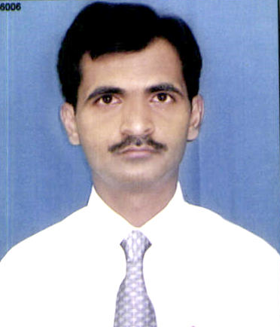

**Teaching and Research Experience**:

16 Years of Teaching Experience.

**Work Experience:**

* Asst. Professor (Grade - II),in Amity School of Engineering & Technology, Lucknow from 05 Oct 2006 – Present.
* Technical Assistant , Instt. of Technology & Mgmt,Gorakhpur,AL-1, Sector-7 GIDA, Gorakhpur from 01 Aug 2003 - 28 Sep 2006

**No. of publications: 36**

**Participation in Conference/Seminars:21**